Project idea:
Ecounity is an innovative company that combines recycling with artificial intelligence. Our mission is to create a smarter, cleaner, and more sustainable world. We use AI-powered systems to identify, sort, and process recyclable materials efficiently. Smart sensors and machine learning help reduce human error and waste contamination. Our technology improves recycling rates while lowering costs for communities and industries. EcoUnity also educates people about sustainable habits through interactive AI platforms. By merging technology and environmental care, we make recycling faster and smarter. Together, we build a unified future where technology serves the planet.
Team members:
- Aya Hany Madkour
- Rahaf Mohamed Elsawy
- Shams Osama Fathy
- Fatma Abdelhamid El-Said
- Jana DiaaEldin Elrefaie

Work plan:
Our targeted audiances:
- Families & Individuals:
People interested in the environment who want to simplify waste sorting and recycling in their daily lives.
- Organizations & Businesses:
Companies, factories, and offices looking for smart solutions to manage waste more efficiently and sustainably, while benefiting from recyclable resources.
- Universities & Schools:
Educational institutions aiming to teach students about sustainability and the importance of recycling, fostering good environmental habits from an early age.
- GNOs & Community Environmental:
Organizations and individuals seeking to support eco-friendly projects and promote environmental awareness.
- Cities & bodies Government:
Municipalities and agencies responsible for waste management, aiming to increase recycling rates and turn waste into economic and environmental value.

Challenges :
1-Difficulty in accurately and efficiently sorting waste.
2-Low environmental awareness among individuals and businesses.
3-Wastefulness and underutilization of recyclable resources.
4-Lack of integrated and user-friendly recycling systems.

Logo design:
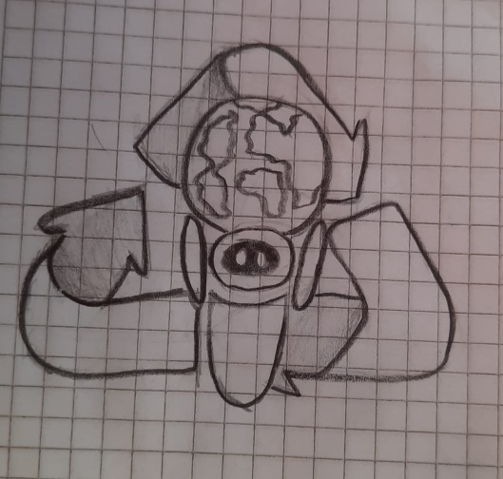
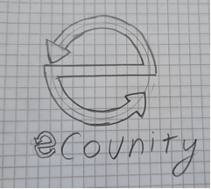
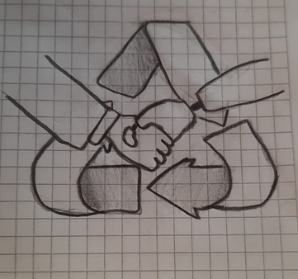

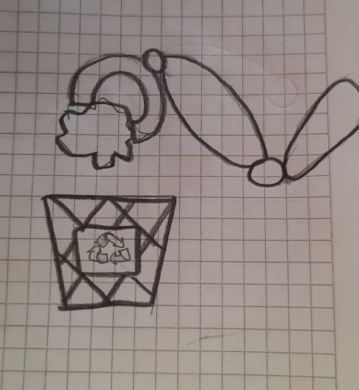
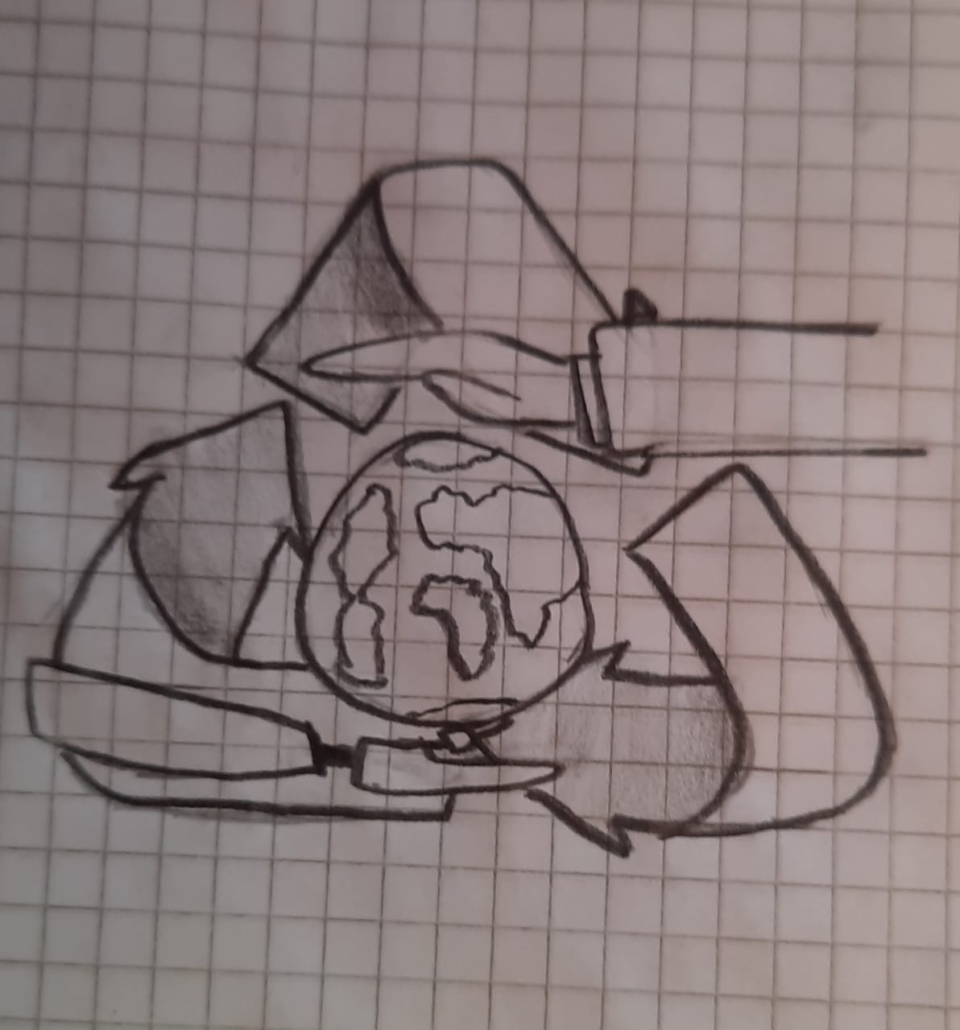

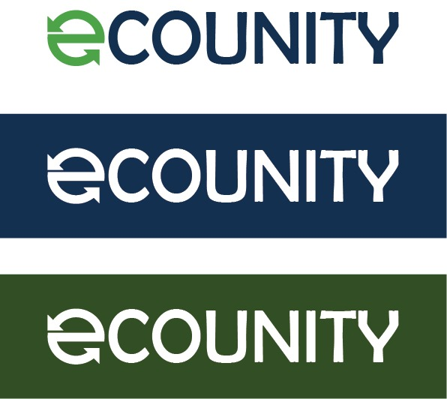

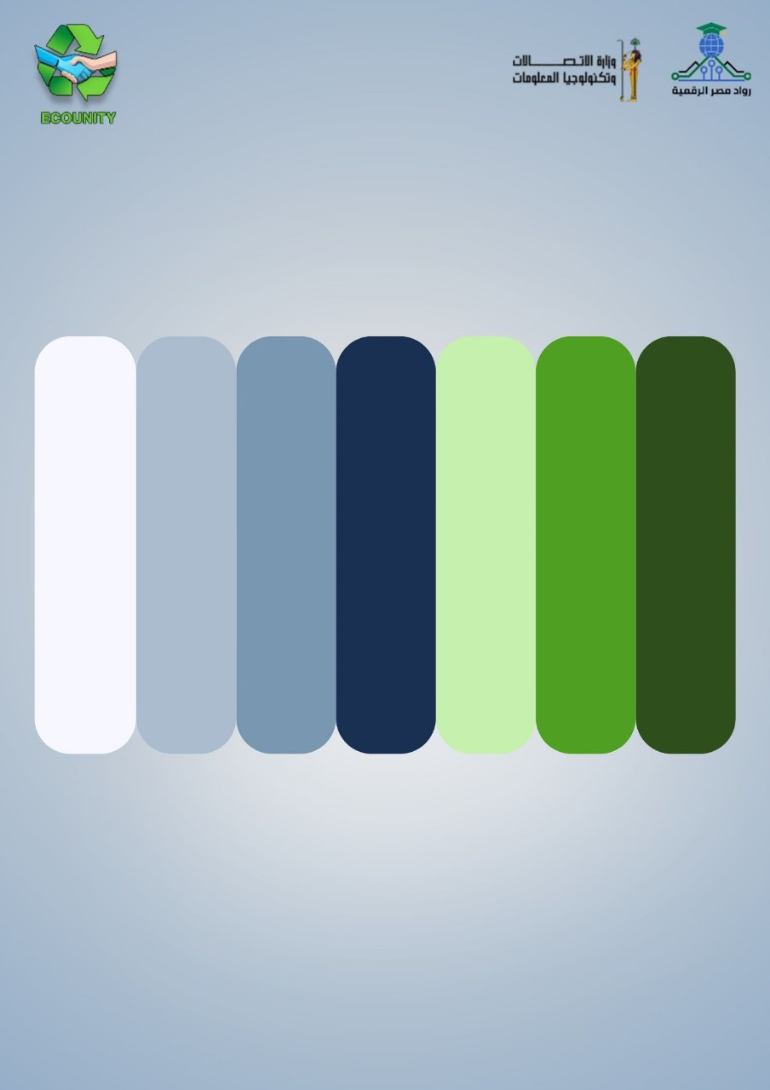

Color palette:

Main degigns:

Complementary product:

Team Review:
Our team at Equanimity has worked collaboratively to develop a project that combines sustainability with modern technology. Each member contributed unique ideas that strengthened the vision of creating an AI-powered recycling system. We demonstrated creativity, problem-solving, and strong communication throughout the project. The teamwork was efficient, as members supported each other in research, design, and presentation stages. We also showed great enthusiasm for addressing environmental challenges using smart solutions.
Areas of Improvement:
While our teamwork was successful, we identified some areas for growth. We can improve our time management by setting clearer weekly goals and deadlines to ensure steady progress. Another area to enhance is technical skill development, especially in AI model training and data analysis, to make our system more accurate and efficient. We should also work on presentation and marketing skills to better communicate our ideas to the public and potential investors.

Final presentation:

Roles & Responsibilities:
- Shams Osama Fathy
-Visual identity
-Website interface
-Rollups (2)
-Business card (5)
-IDs
- Jana DiaaEldin Elrefaie
-Letter head
-Jacket folder
-Facebook cover
-Facebook profile
- Aya Hany Madkour
-Facebook posts (3)
-Envelope (2)
- Rahaf Mohamed Elsawy
-Flyer
-Brochure
-Block note
-Vector info
-Stickers
- Fatma Abdelhamid El-Said
-Instagram posts (4)
-Billboard
-Calander
-Mobile application

Our instructor:
Eng. Mohamed Jamea
Project file:

